**alternating_gaps**

test_iter_5_features_17_num_test_envs_70

{"avg_expansions": 312.7857142857143, "avg_loss": 13.539989363008626, "avg_path_cost": 348.6682867772995, "avg_time_taken": 1.0983559574399675, "num_solved": 70}

train_iter_1_features_17_num_train_envs_1_num_valid_env

{"avg_expansions_per_iter": [15640.0], "avg_path_cost_per_iter": [630.2497833620569], "avg_time_per_iter": [68.97504997253418], "dataset_size_per_iter": [60], "num_solved_per_iter": [1], "train_loss_per_iter": [0.0], "validation_loss_per_iter": [178.82255950856]}

**gaps_and_forest**

test_iter_5_features_17_num_test_envs_70

{"avg_expansions": 809.2285714285714, "avg_loss": 13.929212177184157, "avg_path_cost": 576.46972857136939, "avg_time_taken": 4.841378886359078, "num_solved": 65}

**mazes**

train_iter_5_features_17_num_train_envs_200_num_valid_

{"avg_expansions_per_iter": [1326.2857142857142, 1027.0714285714287, 925.8, 1001.3428571428572, 1034.9], "avg_path_cost_per_iter": [425.12307125599409, 414.72577376678646, 414.715638729224, 423.97456575323861, 419.24335671415508], "avg_time_per_iter": [6.805465255464826, 5.237534270967756, 4.5146735395704, 5.1013509409768245, 5.567620205879211], "dataset_size_per_iter": [1650, 3787, 5522, 7050, 8681], "num_solved_per_iter": [70, 70, 70, 70, 70], "train_loss_per_iter": [25.323597562468475, 23.174327532427139, 22.325738268400897, 22.188919033727132, 21.908377406754433], "validation_loss_per_iter": [18.259673102096965, 16.628550573464075, 17.077453910682742, 16.887924573378157, 18.901070714552656]}

**multiple_bugtraps**

train_iter_5_features_17_num_train_envs_200_num_valid

{"avg_expansions_per_iter": [3575.1285714285714, 4174.728571428572, 3903.5714285714284, 3464.5285714285715, 3426.942857142857], "avg_path_cost_per_iter": [430.21166737030535, 468.53975849411074, 429.30008416681204, 427.5723661818808, 424.49225073882064], "avg_time_per_iter": [16.15289874758039, 24.130447064127242, 18.9738696541105, 17.779640916415623, 17.5261574949537], "dataset_size_per_iter": [4634, 11212, 18556, 25640, 32163], "num_solved_per_iter": [70, 70, 70, 70, 70], "train_loss_per_iter": [29.019266123192491, 27.216193724014808, 27.777679823664961, 27.193507315785283, 26.768593793129391], "validation_loss_per_iter": [26.265350066458527, 25.07784732700302, 21.782796791011137, 20.398681783119777, 20.243583646139054]}

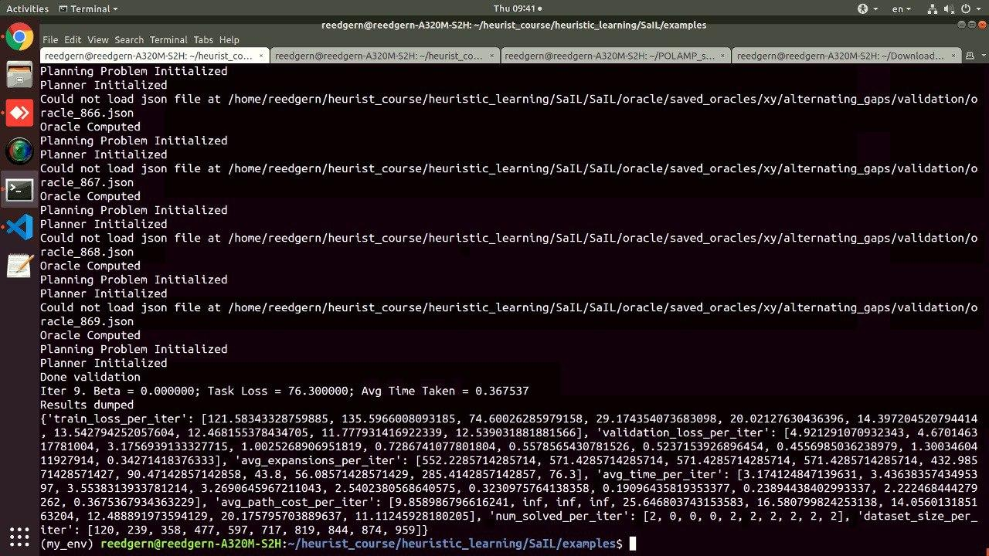

Параметры обучения

